**The Business Plan for Indian Traditional Apparel (Saree)**

**Executive Summary**

Our saree brand aims to establish a strong presence in the ethnic wear industry through high-quality sourcing, strategic marketing, and well-structured financial planning with . The first year will focus on brand positioning, customer acquisition, and expansion into complementary product lines. We will ensure operational efficiency through structured supply chain management, digital marketing strategies, and sustainable growth planning.

**Company Description**

**<<Business Name>>**

**Industry:** Ethnic wear

* **Location:** Bangalore, India
* **Business Structure:** Sole Proprietorship / Partnership Firm
* **Vision Statement:** To become a leading saree brand known for quality, elegance, and affordability.
* **Mission Statement:** To offer premium, handcrafted, and machine-made sarees that blend tradition with modern fashion trends.
* **Goals:** Achieve breakeven within 12 months of the establishment. Create a brand name on marketplace like Myntra, Ajio, Amazon fashion, Nykaa fashion.

**Business Goal**:

**Establish a Strong Brand Presence** in the ethnic wear industry through premium-quality sarees and customer-centric services.

* Capture a Significant Market Share by leveraging e-commerce platforms (Myntra, Amazon, Ajio) and D2C (Direct-to-Consumer) strategies.
* Achieve Profitability & Scalability within 12-18 months, ensuring a steady increase in revenue and brand loyalty.
* Expand Internationally, tapping into the NRI and global ethnic fashion market through online sales.

**Market Analysis**

**Industry Overview**

* **Women's Ethnic Apparel:** In India, the market size for women's ethnic apparel is expected to reach 1.68 trillion Indian rupees by the financial year 2025, up from 747 billion rupees in 2021.
* **Overall Ethnic Wear:** The Indian ethnic wear market is anticipated to grow from approximately USD 197.2 billion in 2024 to USD 558.5 billion by 2033, indicating a CAGR of about 12.6% from 2024 to 2033.
* Increasing demand for High-quality traditional attire among domestic and international buyers.

**Target Market**

* Women aged 20-50, middle to upper-middle-class.
* Online shoppers seeking customized and designer sarees.
* Working professionals looking for comfortable yet stylish ethnic wear.
* Wedding shoppers seeking exclusive and premium sarees.
* NRI customers who prefer Indian ethnic wear for cultural occasions.
* Who is seeking for fast delievery.

**Competitor Analysis**

* **Major Competitors:** Boutique Owners & Independent Designers, Sellers on Myntra, Amazon & Flipkart, Small Businesses, Exhibition-Based Sellers, and Handloom & Traditional Weave Sellers.
* **Strengths of Competitors:** Established customer base, strong supply chain and wide product range due to thousands of sellers selling the variety of products on the same LOB.
* **Weaknesses of Competitors:** Limited customization options, expensive due to high transaction cost on online platform and limited sales due to lower engagement with younger demographics.
* **Our Competitive Edge:**
  + **Creative designers:** Hire the fashion designer professionals for short listing the products as per the trend
  + **Superior Fabric Quality:** Carefully sourced materials to ensure premium touch and feel.
  + **Unique Designs:** Exclusive and limited-edition sarees that stand out.
  + **Affordable Pricing:** Catering to both budget-conscious and premium customers.
  + **Digital Marketing Engagement:** Strong social media presence and influencer collaborations.
  + **Personalization Options:** Custom embroidery and blouse designing services.
  + **Live Shopping Experience:** Interactive shopping via social media platforms.
  + **Fast Delivery & Customer Service:** Seamless order fulfilment and post-purchase support. Immediate delivery within the city limit with the help of porter services

**Organization and Management**

* **Founder & CEO & Finance:** Manages budgeting, cost control, and revenue growth.
* **Operation:** Operation manager manages the Inventory and logistics, customer support and daily operations with the help of two full time workers.
* **Marketing Head:** Marketing head handles branding, social media engagement and advertising with supporting team.

**Products and Services**

* **Saree Collection:** Initial six months will focus only on unique and affordable sarees, ensuring a balance between reasonable pricing and exclusive collections that create a monopoly in the market. Varieties include Silk, Cotton, Chiffon, Georgette, Handloom, and Designer sarees.
* **Customization Services**: Personalized embroidery, blouse designing (to be introduced after six months).
* **Subscription Model:** Monthly curated saree collections for premium members (to be introduced later).
* **Accessories:** Matching jewellery, blouses, and petticoats (to be introduced after six months).

**Marketing Plan**

**Branding & Positioning**

* Create a **strong online presence** via social media marketing and influencer collaborations.
* Develop a professional e-commerce website.
* Engage customers through storytelling and video content.
* Live shows/Q/A, Live quiz and offers

**Sales Channels**

* **Direct-to-Consumer (D2C):** Own website and social media pages.
* **Marketplaces:** Amazon, Flipkart, Myntra.

**Advertising & Promotions**

* **Social Media Ads:** Facebook, Instagram, Pinterest.
* **Festive Campaigns:** Exclusive discounts during festive seasons.
* **Loyalty Programs:** Referral bonuses and repeat purchase discounts.

**Financial Plan**

**Initial Investment Breakdown – Assumption:1 year breakeven**

|  |  |  |
| --- | --- | --- |
| **Expense Head** | **Percentage of Total Investment** | **Amount (₹ in Lakhs)** |
| **Stock Purchase** | 50% | 50 |
| **Marketing Budget** | 10% | 10 |
| **E-commerce Setup (Website, App, etc.)** | 5% | 5 |
| **Warehouse & Storage, Studio Setup** | 8% | 8 |
| **Employee Salaries** | 15% | 15 |
| **Miscellaneous Expenses** | 5% | 5 |
| **Traveling Expenses** | 2% | 2 |
| **Contingency Fund** | 15% | 15 |
| **Total Investment** | **100%** | **100 LAKHS** |

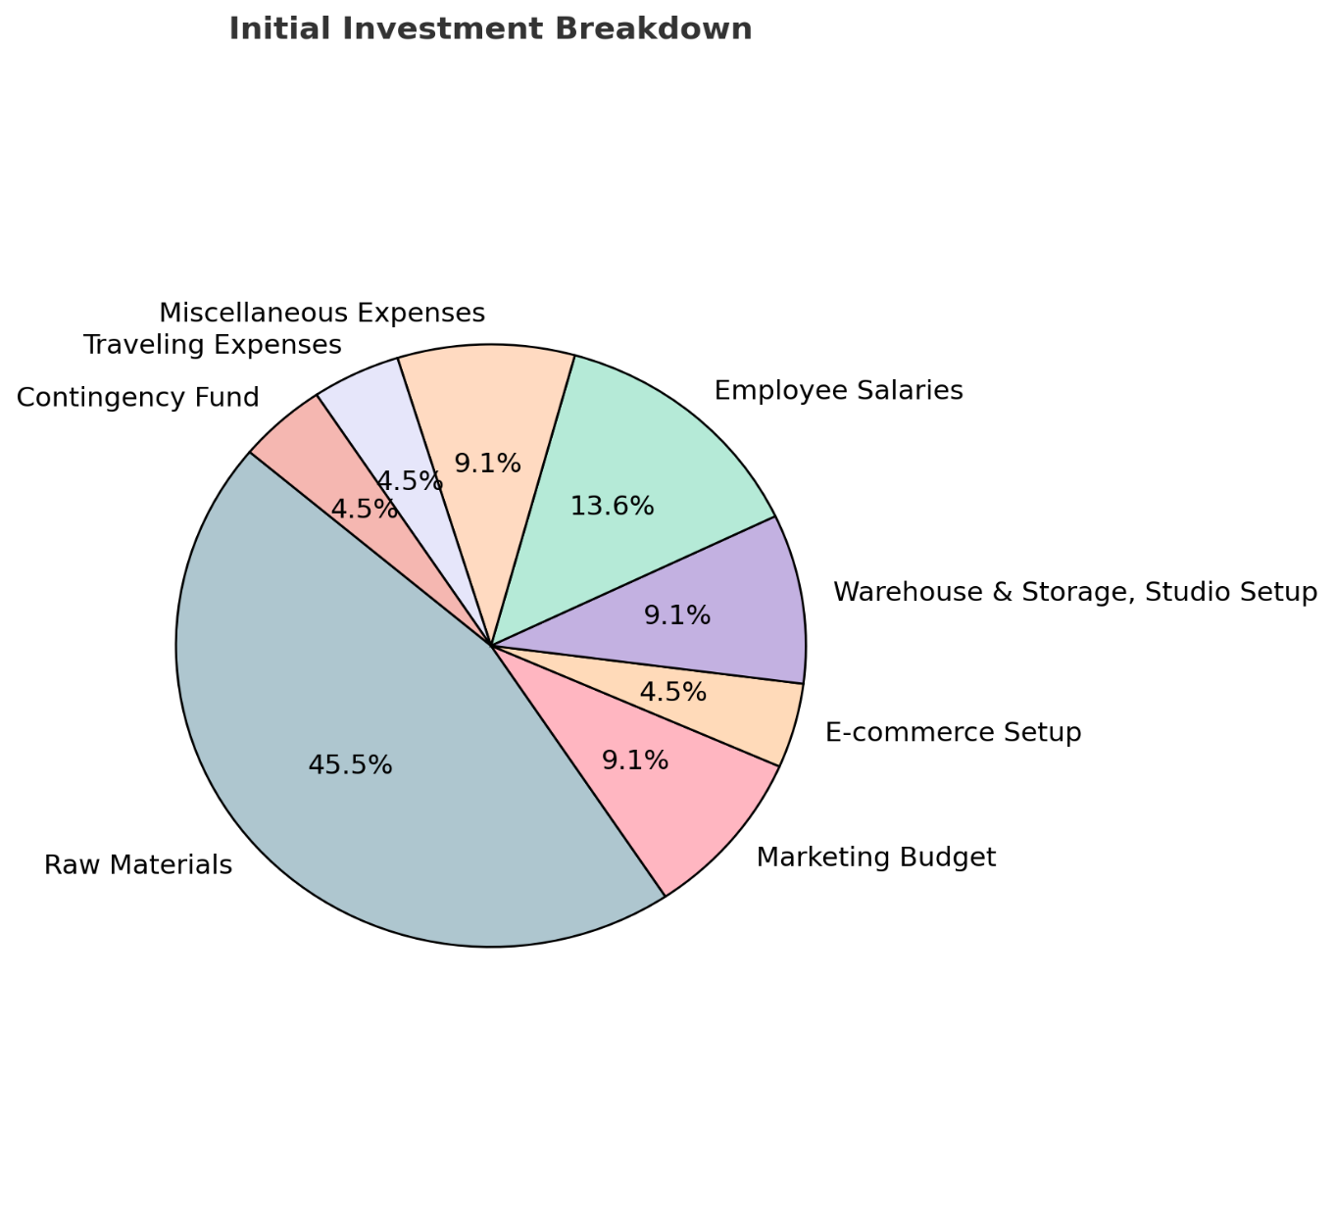

**Revenue Projection**

|  |  |  |
| --- | --- | --- |
| **Month** | **Revenue (₹ Lakhs)** | **Profit (₹ Lakhs)** |
| Month 1 | 5 | 0 |
| Month 2 | 5.5 | 0 |
| Month 3 | 6.05 | 1.5 |
| Month 4 | 6.65 | 2.3 |
| Month 5 | 7.3 | 2.9 |
| Month 6 | 8 | 3.2 |
| Month 7 | 8.8 | 5.3 |
| Month 8 | 9.7 | 7.3 |
| Month 9 | 10.7 | 8.9 |
| Month 10 | 11.8 | 10.6 |
| Month 11 | 13 | 12.5 |
| Month 12 | 14.3 | 14.3 |

**Monthly Milestone Plan**

**Month 1: Business Setup & Initial Marketing**

* Register business, finalize branding, and set up supply chain.
* Develop website and social media profiles.
* Launch pre-marketing campaigns to build anticipation.

**Month 2: Product Launch & Customer Acquisition**

* Introduce first saree collection.
* Implement digital ads and influencer promotions.
* Begin accepting orders through website and social media.
* Start selling on e-commerce platforms like Myntra, Ajio, Amazon and other.

**Month 3-4: Sales Growth & Distribution Expansion**

* Increase stock capacity based on demand.
* Concentrate on social media sale by adopting new ideas.
* Introduce festive offers to attract customers.

**Month 5-6: Scale Operations & Brand Recognition**

* Evaluate product performance and customer feedback.
* Expand into new product categories like embroidered sarees.
* Strengthen customer loyalty programs and referral incentives.

**Month 7-9: concentrate on ecommerce platforms like Myntra, Ajio and other**

* By optimising the product listing.
* Invest in sponsored ads
* Introduce limited-edition collections.
* Launch targeted marketing campaigns for specific regions.

**Month 10-12: New Product Line & Growth Strategy**

* Launch **new complementary product lines** (saree accessories, blouses).
* Expand geographically with nationwide shipping.
* Evaluate financial performance and strategize for Year 2 growth.

**Raw Material & Storage Plan**

* **Sourcing:** Work with ethical handloom manufacturers and textile mills.
* **Inventory Management/ Storage:** Secure warehouse with climate-controlled sections for silk sarees as well as convenient for packing and other operational activities.

**Conclusion**

With a well-structured business plan, strategic financial investments, and an effective marketing approach, our saree brand is poised for steady growth and long-term success. The combination of high-quality products, competitive pricing, and strong digital presence will create a loyal customer base and drive consistent revenue. By continuously innovating and adapting to market trends, we will expand our offerings and establish a reputable name in the ethnic wear industry. Through a phased approach to scaling operations, leveraging digital marketing, and ensuring superior customer engagement, we aim to become a leading brand in the saree industry within the next few years.

**Appendix**

* **Market Research Reports** – Detailed data on market trends, customer preferences, and industry insights.
* **Supplier Agreements** – Contracts and agreements with manufacturers and raw material suppliers.
* **Customer Persona Profiles** – Detailed demographic and psychographic information about target customers.
* **Legal Documentation** – Business registration, GST details, trademark applications.
* **Financial Projections Sheet** – Detailed breakdown of revenue forecasts, profit margins, and cash flow analysis.
* **Marketing Plan Document** – A structured plan for online and offline promotional activities.
* **Competitor Analysis Report** – SWOT analysis of major competitors with pricing and market share details.
* **Production & Inventory Plan** – Strategy for sourcing, stocking, and managing saree collections.
* **Sales & Distribution Plan** – Details on retail partnerships, e-commerce strategies, and wholesale agreements.